Soft Robotics

*Make*

*By Matthew Borgatti | Kari Love*

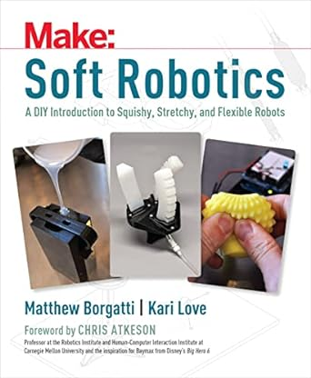

# Preface: Why You Should Care about Soft Robotics

# CHAPTER 1: Introduction to Soft Robotics

## The Breadth of Soft Robotics

## What Is It Good For?

## Where Are the Soft Robots?

## Challenges

# CHAPTER 2: Soft Robotics for Space Exploration

## Advantages of Soft Technologies for Space Exploration

## Bioinspired Robotic Rovers

## Working Alongside Astronauts

## Space Suits

## Expandable Habitats

## Challenges and Setbacks

# CHAPTER 3: Using a Water Snake Toy to Move Like an Amoeba

## Project 1: Shooting BeadsProject 2: Rolling Mechanism

# CHAPTER 4: Cable Pull Mechanisms— Ready, Willing, and Cable

## Project 1: Simple Finger

## Project 2: Tripod Actuator

# CHAPTER 5: McKibben Muscles—Strong and Flexible

## Project: McKibben Muscle

# CHAPTER 6: 3D Printing Best Practices

## Printing Settings

## Inspecting and Finishing

# CHAPTER 7: The Remora—A Vacuum-Powered Jamming Gripper

## Project: Building the Remora Gripper

# CHAPTER 8: Mixing and Casting Silicone

## Silicone

# CHAPTER 9: Building Your Own Vacuum Chamber

## Project: Building the Vacuum Chamber

# CHAPTER 10: The Bibenda—A Simple Pneumatic Bending Actuator

## Project: Building the Bibenda Actuator

# CHAPTER 11: The Pneumatic Hand Pump — A Soft Robot Prototyping Tool

## Project: Building a Pneumatic Hand Pump

# CHAPTER 12: The Kousa—A Soft Hydraulic Pressure Sensor

## Project: Building the Kousa

# CHAPTER 13: The Kestrel—A Soft Pneumatic Gripper

## Project: Building the Kestrel Gripper

# CHAPTER 14: Soft Robotics Pneumatic Power Supply

## Project: Building the Soft Robotics Power Supply